Decentralized Examination Platform for Secure Question Papers

Across nation many states are suffering from issues of exam paper leakage because of centralized server paper management. Centralized server database can be easily hacked, leaked or tamper by experienced database administrator and currently no tool exists to detect such database manipulation.

To overcome from above issue we are proposing concept of managing exam paper in Blockchain server. Blockchain has inbuilt support for data security, tamper proof and secured data storage. Blockchain store each record as transaction/block and associate each block with unique hashcode and this hashcode will get verify for subsequent block storage, if any block tamper then result into mismatch hashcode and data tamper will get detected. Blockchain allow only authenticated user to access or view data. Currently no way exists to hacked or alter Blockchain data.

To manage MCQ question paper in Blockchain we have designed following modules which can run by different users such as Admin, Teacher and Student

1. Admin: admin can login to system using username and password as ‘admin and admin’. After login admin can Add New users such as Teachers and students. Admin can view all questions added to Blockchain and can view marks obtained by each student
2. Teacher: teacher can login to systems and then store questions in Blockchain. Blockchain designed to store small amount of data so we are saving all questions to IPFS and its storage hashcode address will get saved in Blockchain. Later we can retrieve questions from IPFS by getting its hashcode from Blockchain. Teacher can view all students marks
3. Student: student can login to system and then write exam and can view obtained marks along with correct answer and his given answer.

Blockchain can store and retrieve data using SMART CONTRACTS which can be designed using SOLIDTY programming. This contract contacts functions which can be called from any programming language to save and get data from Blockchain. To manage question paper we have designed following smart contract

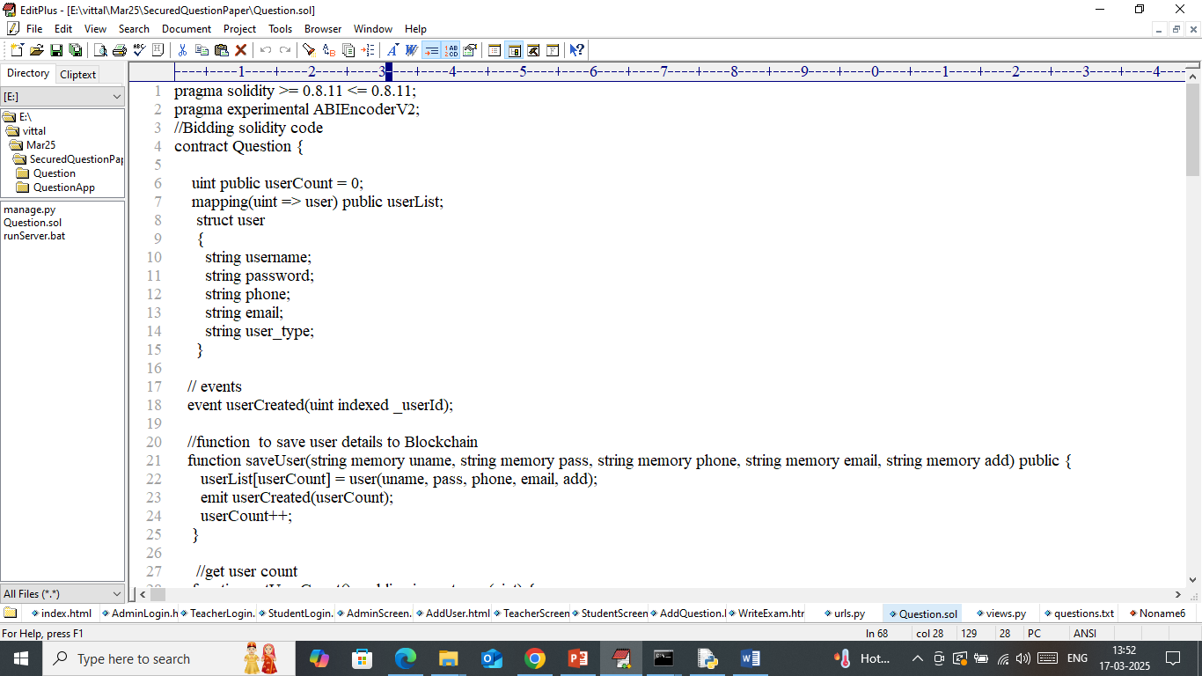

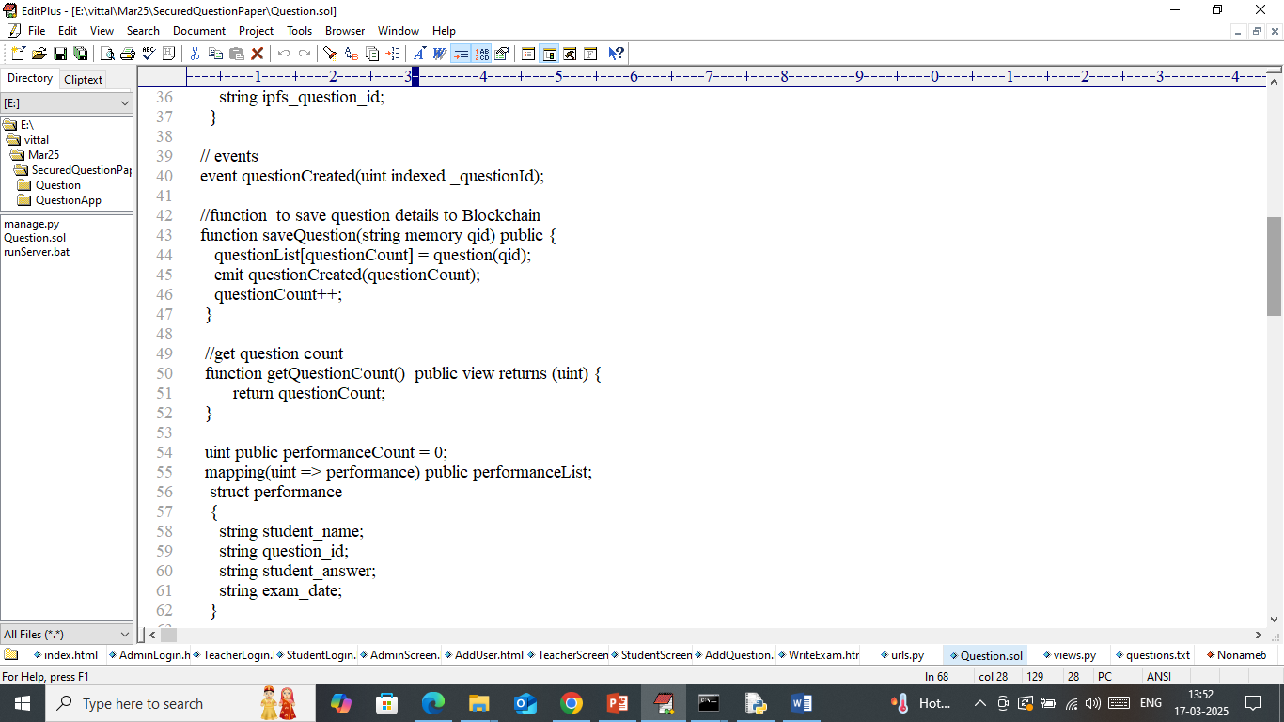

In above smart contract code we define functions to manage students and teacher details along with question paper and student performance. Now we need to deployed above contract to Ethereum using below steps

1. First go inside ‘hello-eth/node-modules/bin’ folder and then look and double click on ‘runBlockchain.bat’ file to start Ethereum and then will get below page
2. 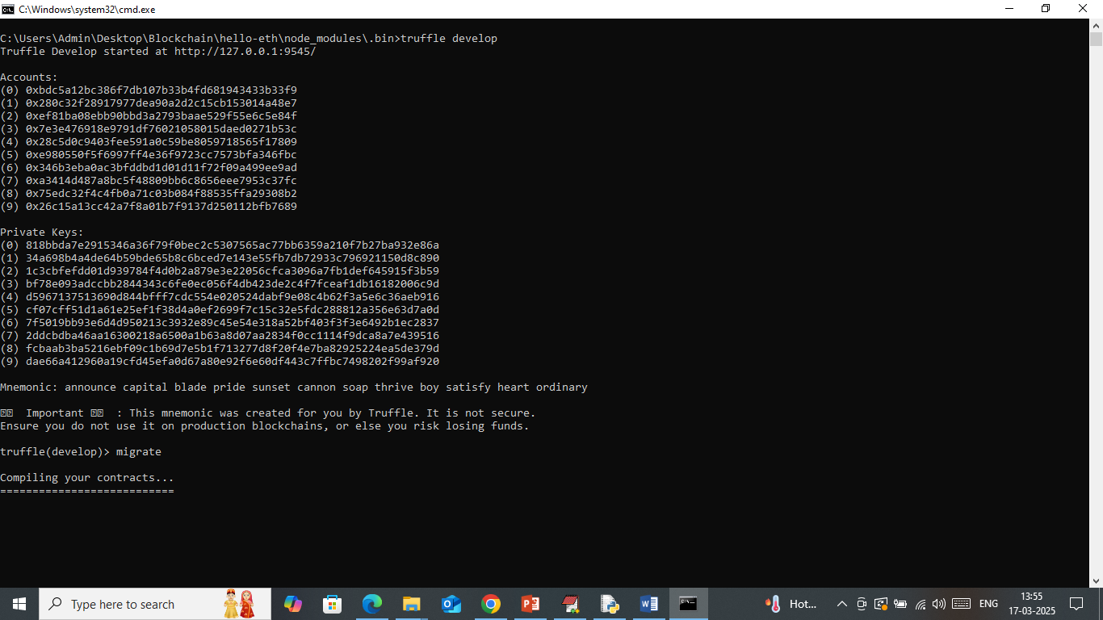
3. In above screen Ethereum started with default account and private keys and now type command as ‘migrate’ and then press enter key to get below page
4. 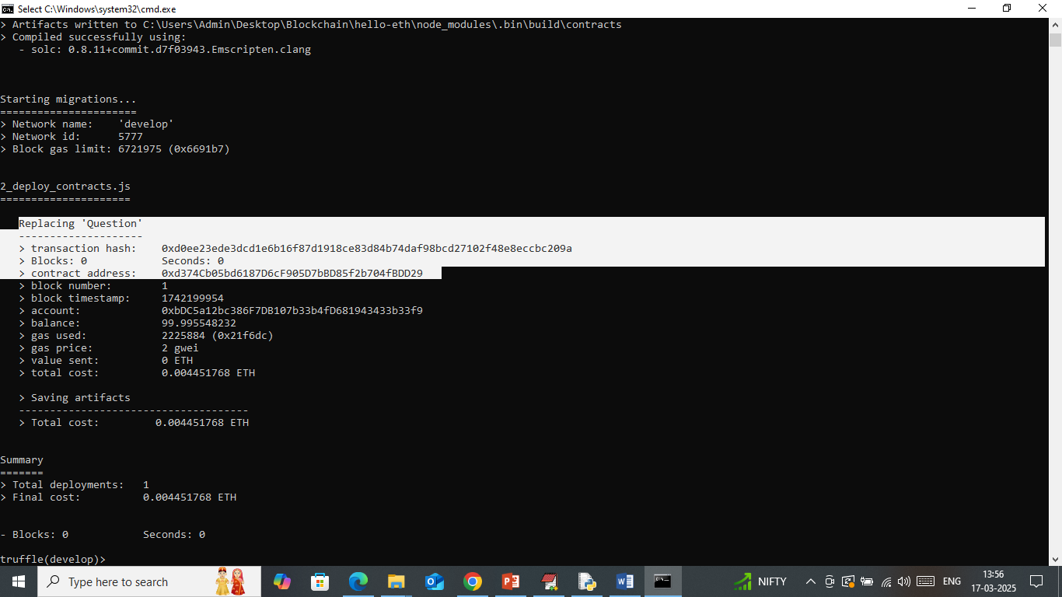
5. In above screen in white text can see ‘Question’ contract deployed and got contract address and this address can be specified in Python code to call above contract. In below screen showing python code calling above contract
6. 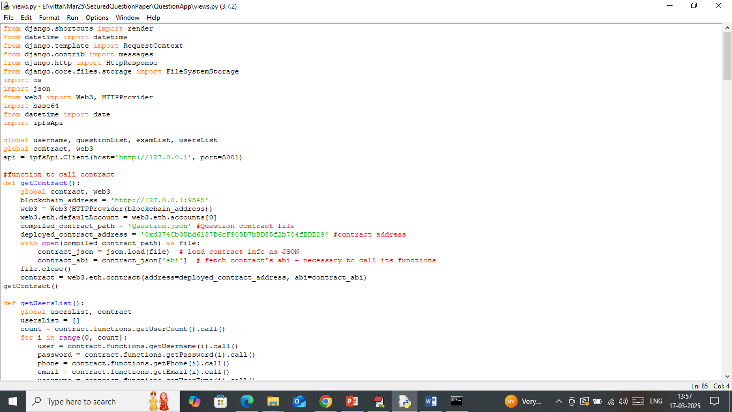
7. In above screen read red colour comments to know about contract calling using contract address. In above black console we have seen contract deployed and running successfully and let it run till you execute code.

Now double click on ‘Start_IPFS.bat’ file to start IPFS server and then will get below page

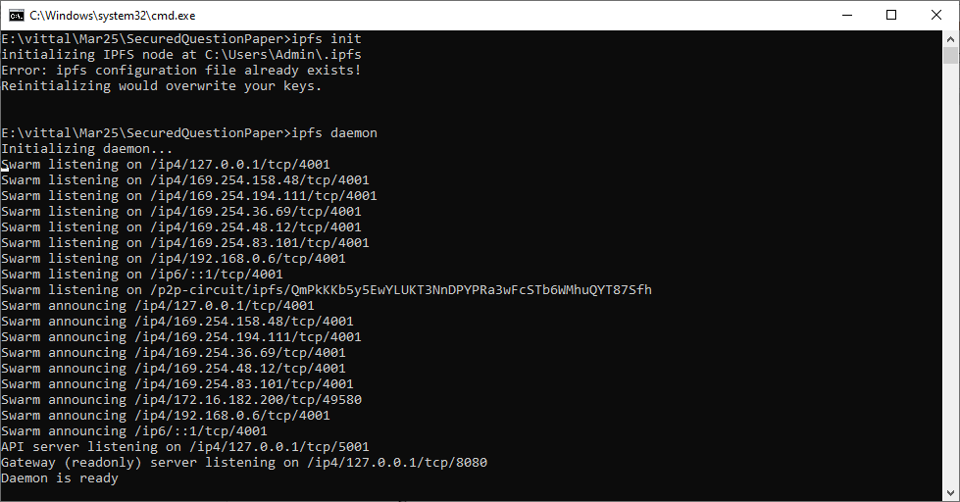

In above screen IPFS server started and let it run till execute code. Now double click on ‘runServer.bat’ file to start python web server and then will get below page

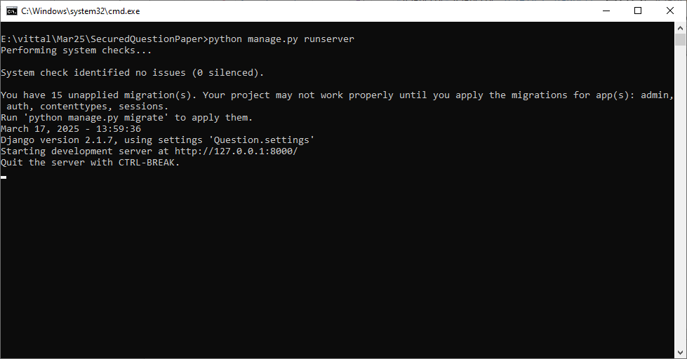

In above screen python server started and now open bowser and enter URL as <http://127.0.0.1:8000/index.html> and then press enter key to get below page

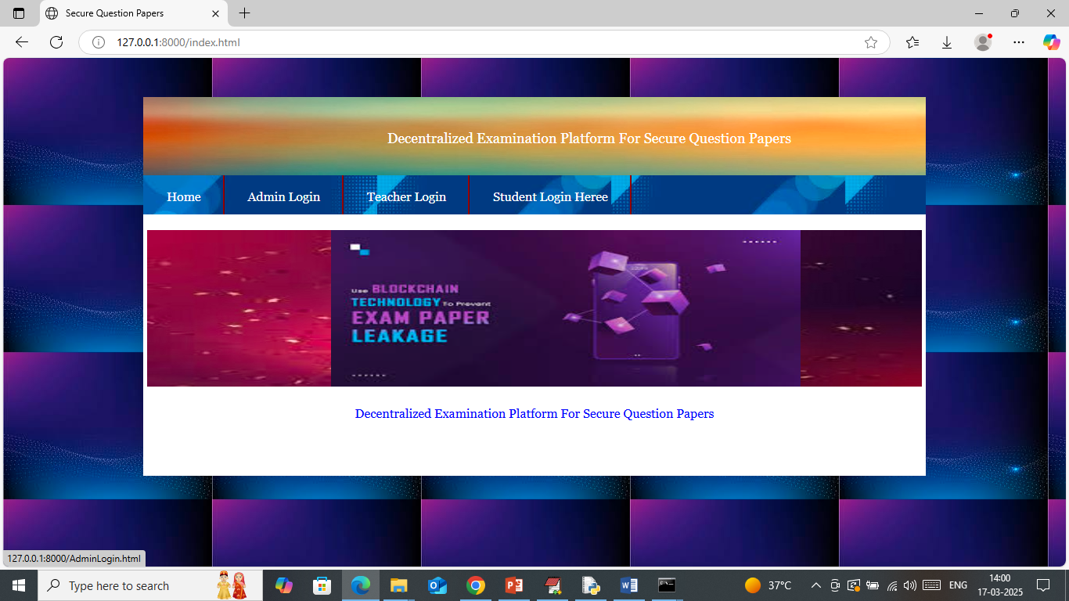

In above screen click on ‘Admin Login’ link to get below page

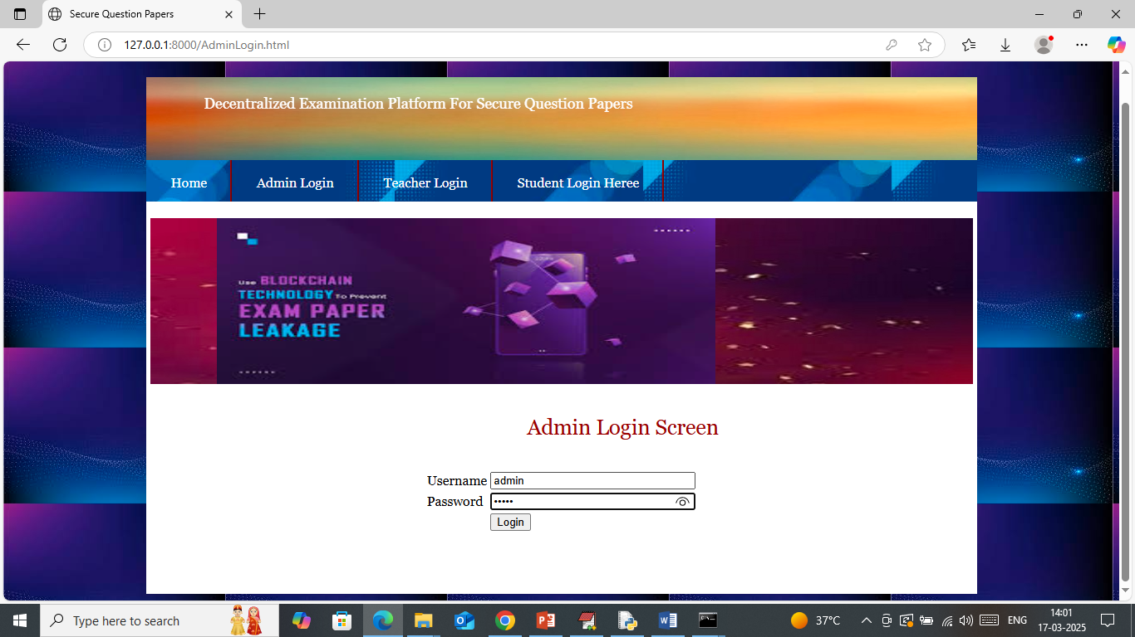

In above screen admin is login and after login will get below page

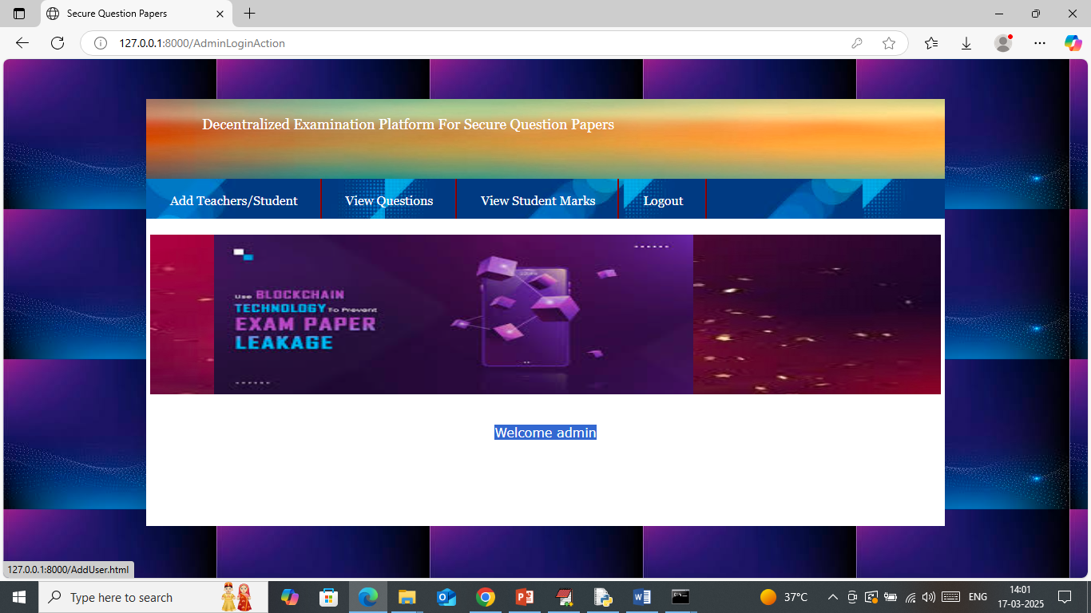

In above screen admin can click on ‘Add Teacher/Student’ link to get below page

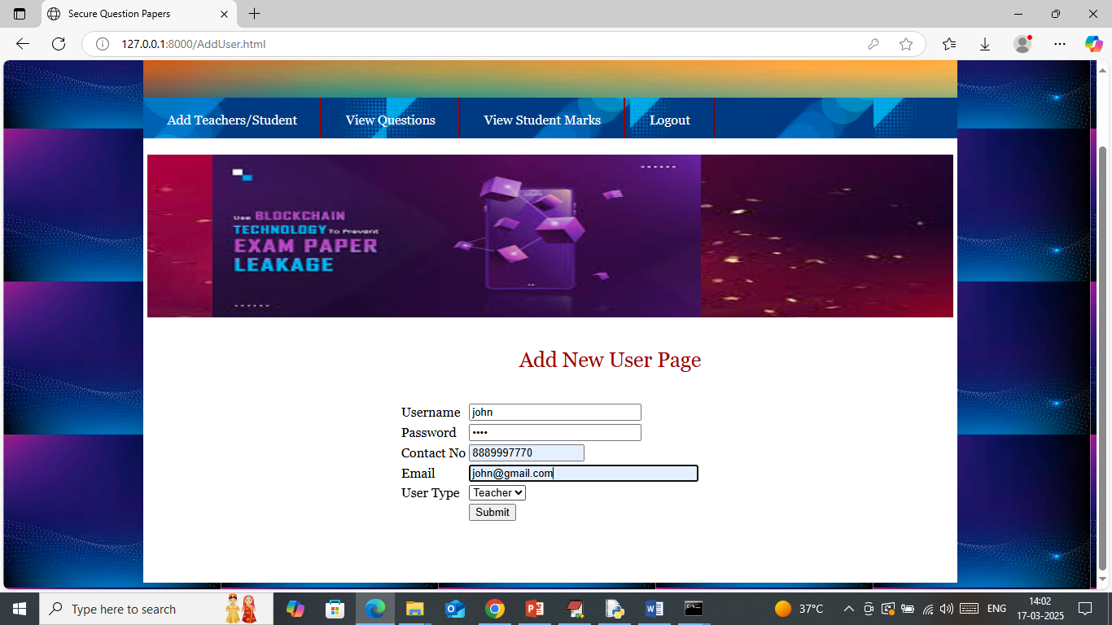

In above screen admin is adding teacher details and then press button to save details in Blockchain and then will get below page

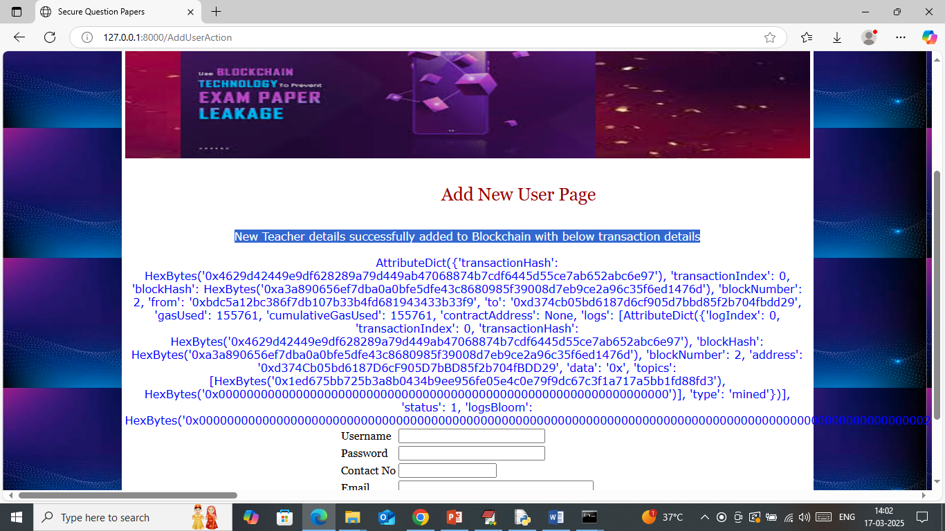

In above screen teacher details added to Blockchain and then I am displaying entire log obtained from Blockchain after storage. Above log contains details like Block no, transaction no, hashcode and many other details. Similarly you can add other teachers and students.

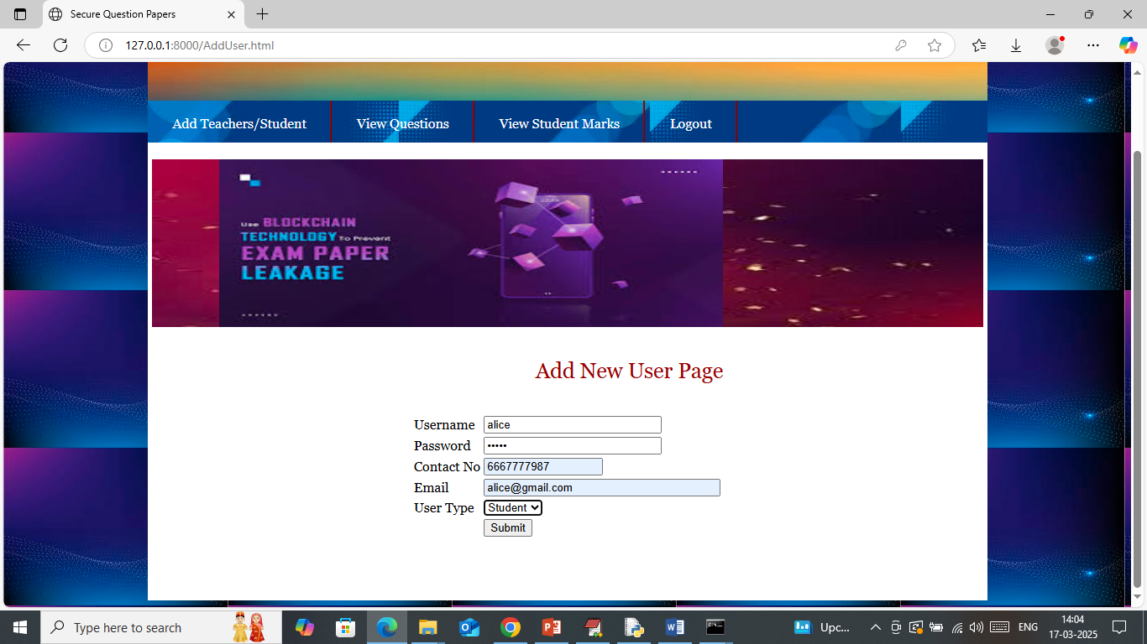

In above screen adding student details and then press button to get below page

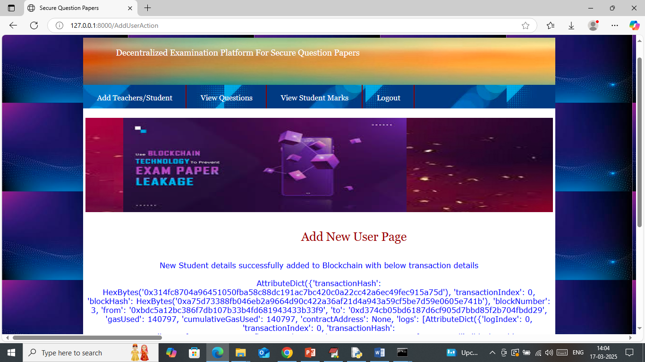

In above screen student details also added and now logout and login as Teacher to add questions

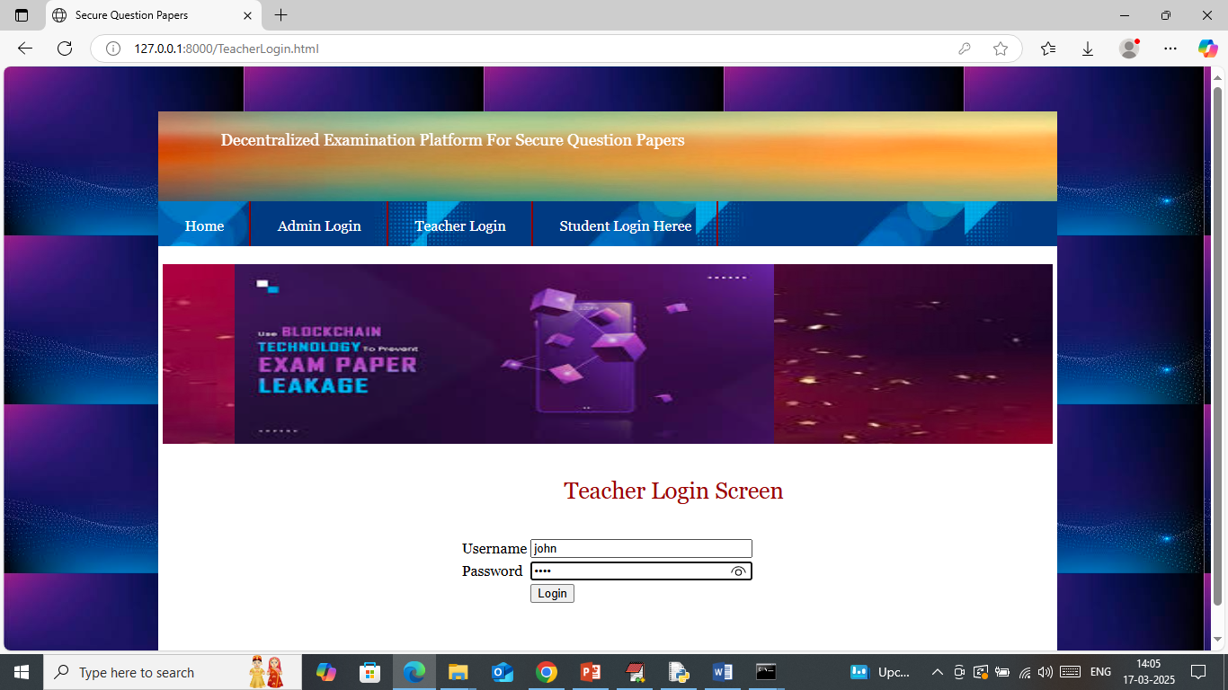

In above screen teacher is login and after login will get below page

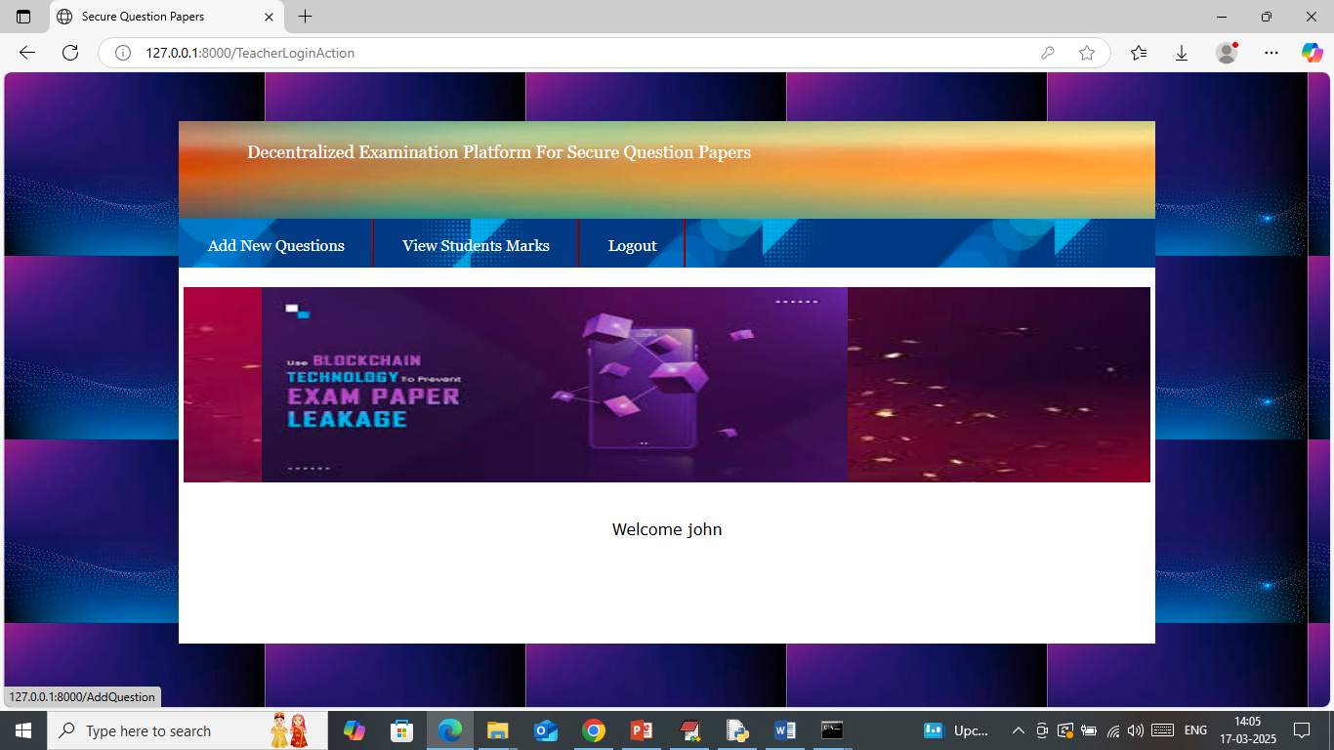

In above screen click on ‘Add New Questions’ link to get below page

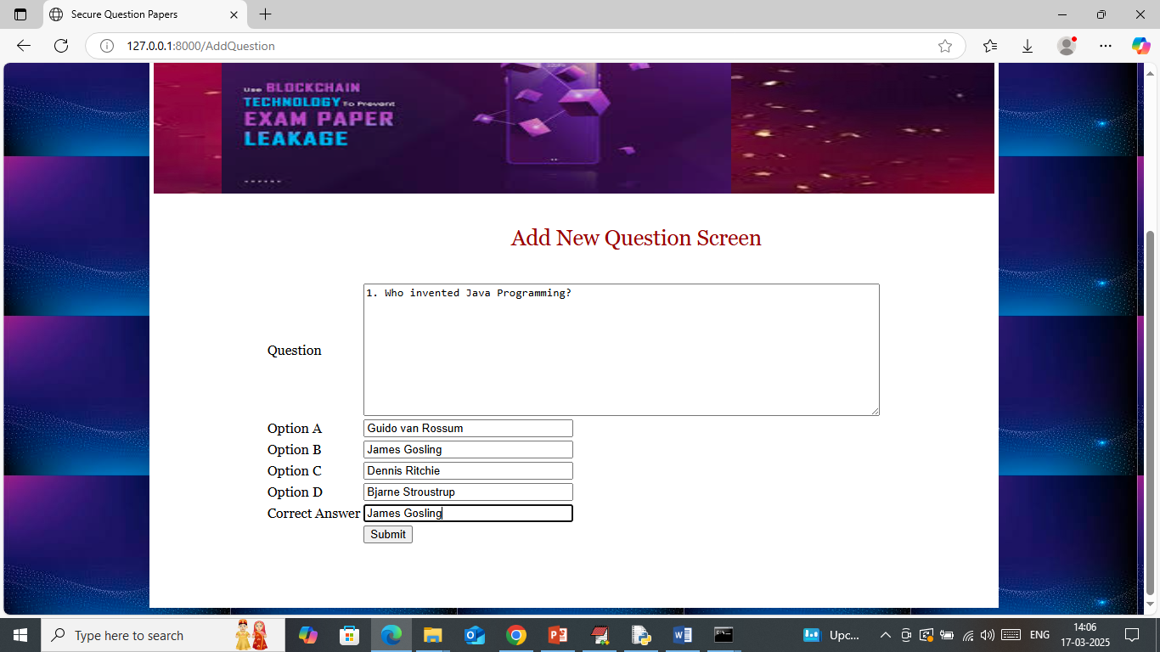

In above screen add new question along with options and correct answer and then press button to add question to Blockchain and then will get below page

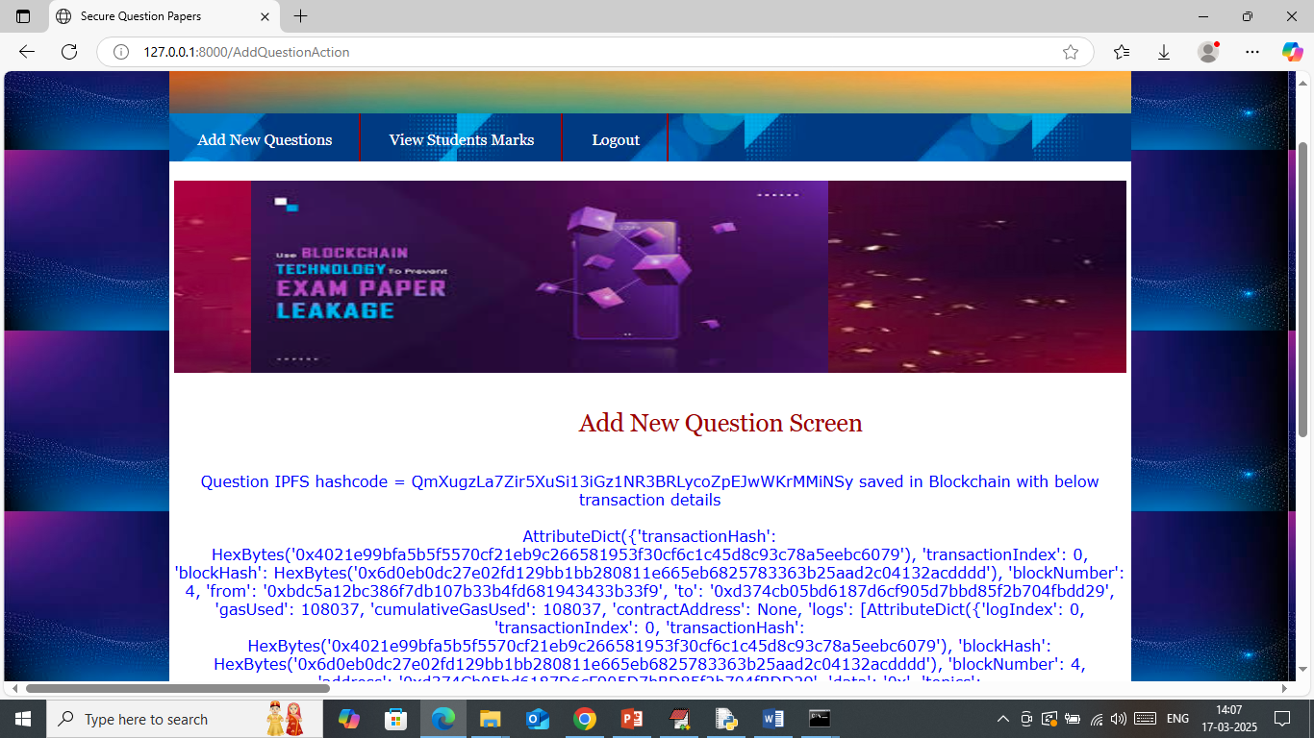

In above screen question details added to Blockchain and similarly you can add as many questions as you want. Now logout and login and ‘Student’ to write exam

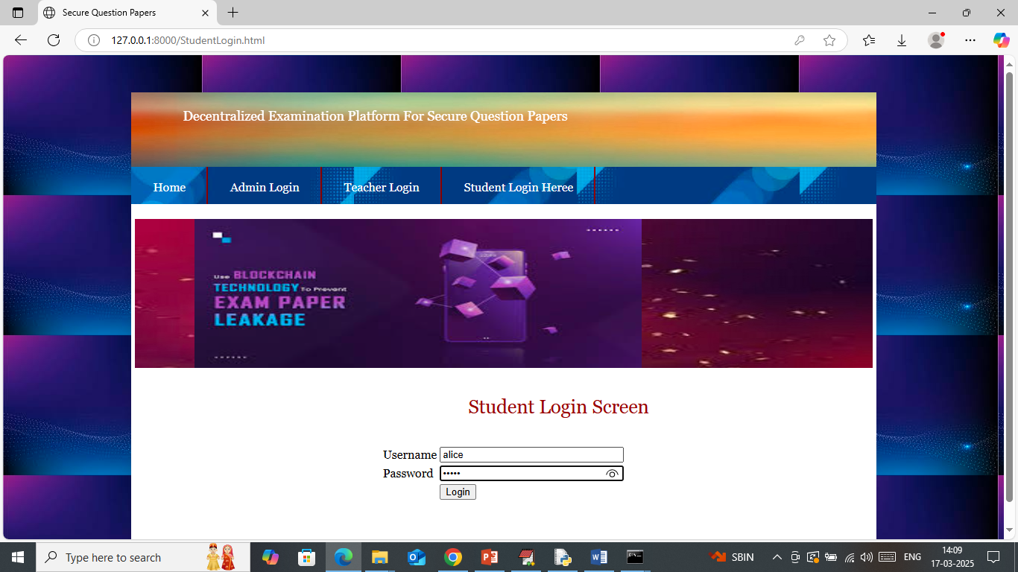

In above screen student is login and after login will get below page

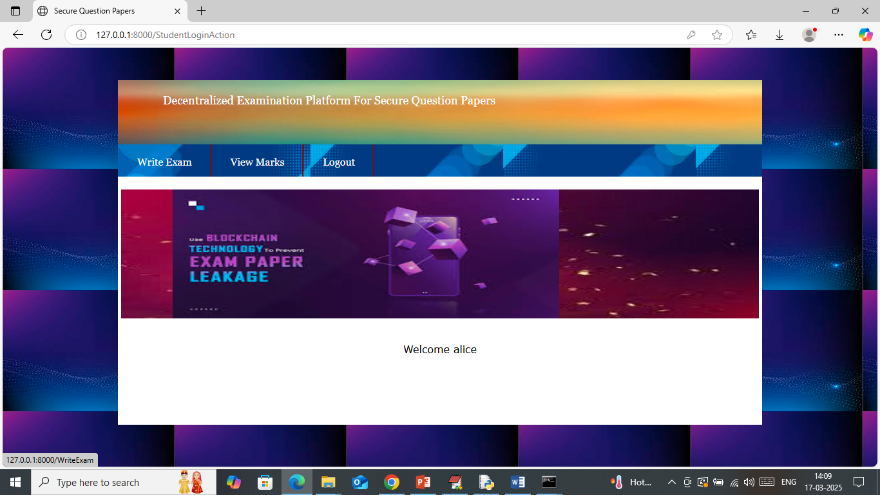

In above screen click on ‘Write Exam’ link to get below page

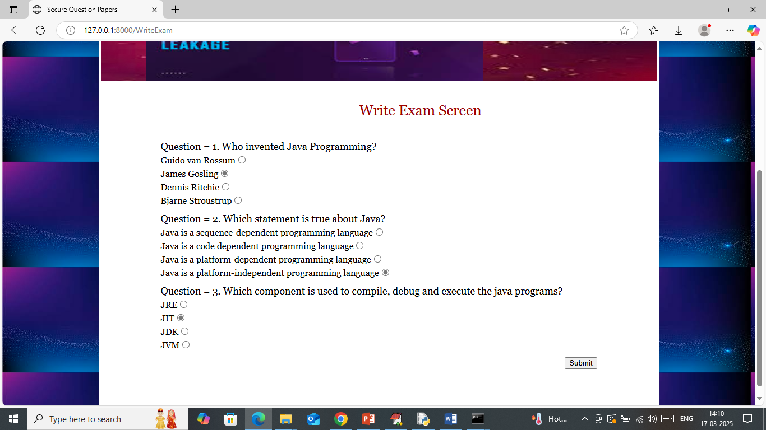

In above screen student will select correct answer radio button and then press ‘Submit’ button to get below page

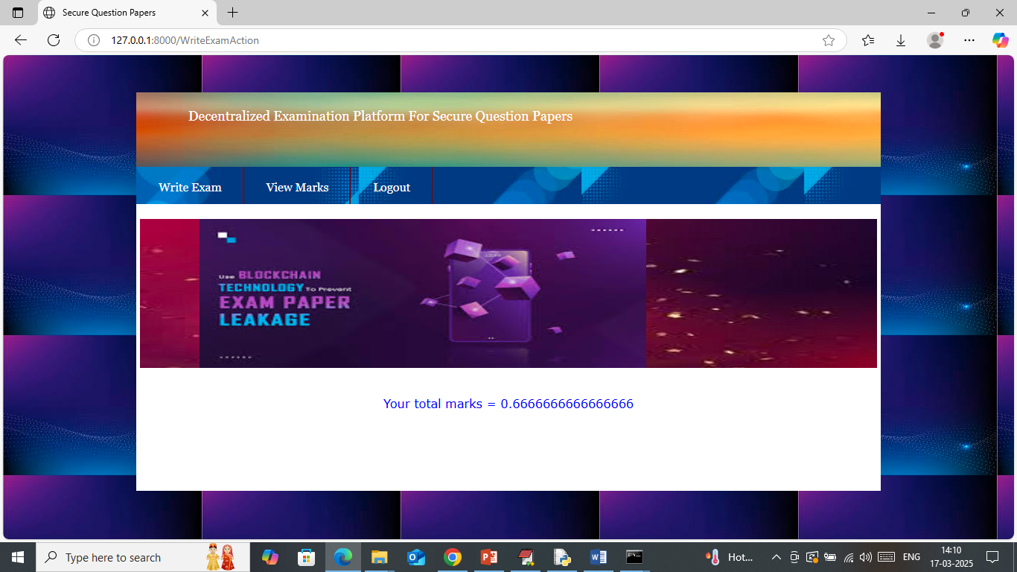

In above screen in exam student got 66% marks and now click on ‘View Marks’ link to get below page

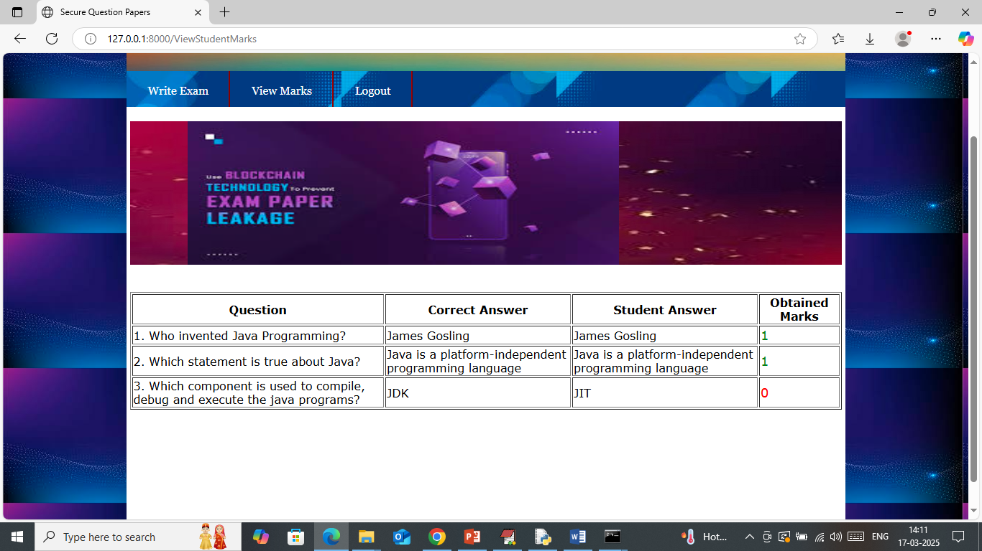

In above screen student can see question along with correct answer and his answer and if both answers are correct then student will get 1 mark else 0. Now logout and login as ‘admin’ to view question and marks

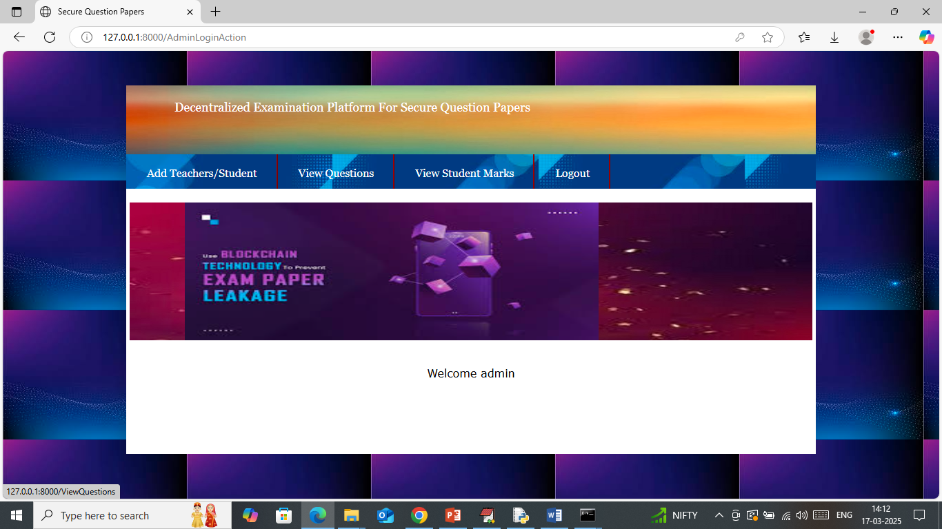

In above screen admin can click on ‘View Questions’ link to get below page

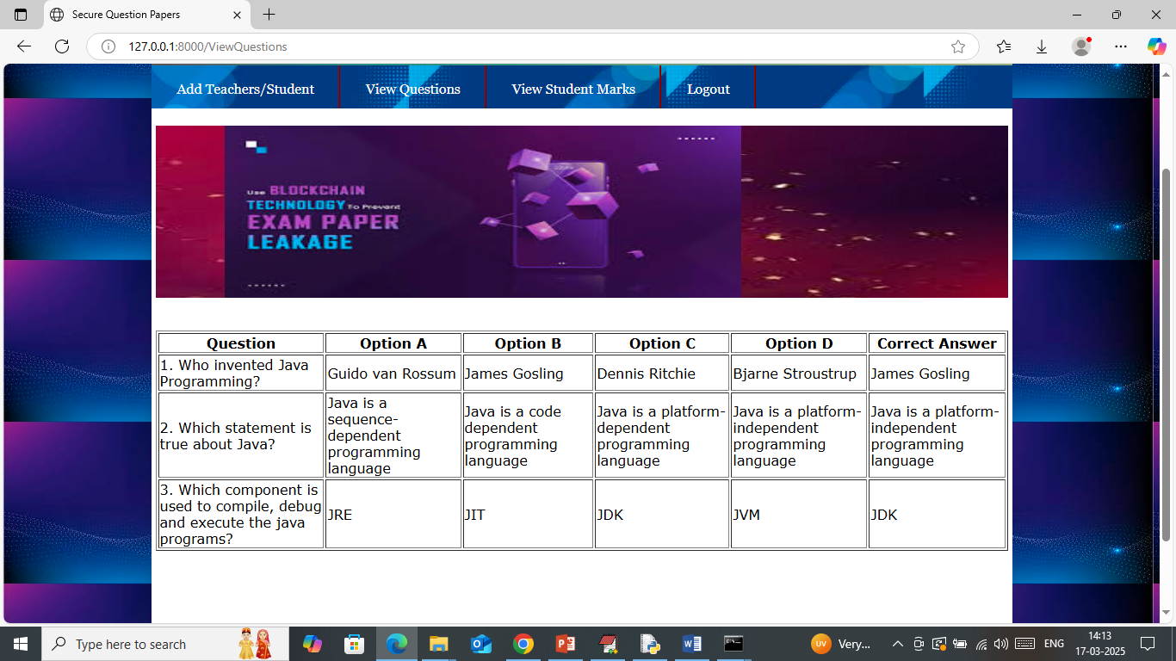

In above screen admin can view all question details added by Teacher and now click on ‘View Mark’ link to get below page

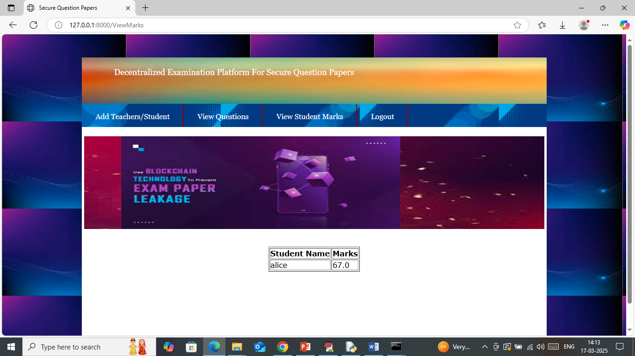

In above screen admin can view ‘Alice’ student wrote exam and got 67% marks.

Similarly by following above screens you can run complete project

Note: you ask for MFA login but GMAIL and SMS based MFA required paid account so we have not added this part.